**Social Data Analysis and Visualisation: Preliminary Project Investigations**

* An explanation of the central idea behind your final project (what is the idea? which datasets do you need to explore the idea?, why is it interesting?)

The 2019 - 2020 Coronavirus pandemic will be one of the most influential health crisis of the 21st century. COVID-19, the strain responsible for the pandemic, is a new strain of coronavirus, not previously identified in humans, causing respiratory stress and disease. The health impact continues of the virus is of great concern world-wide. However, the economic impact of the COVID-19 pandemic will continue to be felt for months after the virus has gone. Over the past several weeks, the global share market has dropped, businesses have closed, and governments have been forced to pledge funds to the race to find a vaccine and to help the struggling economy. Governments worldwide have introduced totalitarian social distancing and lockdown laws.

In this project, the link between coronavirus, government and economic data will be drawn upon to compare the response of governments to the pandemic across the Europe. Through the use of coronavirus data including cases by day and country, government data including dates and measures introduced to slow the virus as well as funding pledged in the race to find a vaccine and finally economic data including country debt, GDP, etc, this investigation will analyse how various country indicators have influenced governments responses to the pandemic. Information on the number of hospital beds and healthcare workers will also be sourced to see if there is any correlation between the capacity of the healthcare system and the government measures that have been put into place. This information will be interesting to find links between adopted measures and consequences of the spread of the pandemic. It will also be interesting to see how a countries wealth has impacted the number of coronavirus cases and the government measures that have been enforced.

To explore this idea, economic indicators for example corruption index, GDP and debt will need to be sourced. This information has been retrieved from the world bank data archive. A plethora of data is available from this source and as such, indictors further to the ones listed above have also been found and identified as interesting to the analysis to be conducted. A dataset online containing the government measures introduced worldwide by date was sourced. Finally, coronavirus data, including number of cases, deaths and recovered patients by day was sourced from <https://data.humdata.org/dataset/novel-coronavirus-2019-ncov-cases>. To utilise all of this data, each dataset was individually cleaned and the country codes and names normalised to allow for easy comparison between the datasets. Each dataset contains many attributes and observations. These will need to be filtered and narrowed down to attributes that are relevant and important for this investigation.

* A mock up of the visualization that you wish to build. (Anything is fine here. Pen and paper, MS Paint, Inkscape, D3, anything.).

Decide on 3/4 visualisations for part A and then if we decide to add more that’s fine.

See below ideas for visualisations, I think if we go ahead with the drawing style video, pen and paper of the mock-up visualisations will be fine. This is also probably the easiest way to do the mock-ups without having to fiddle around with an online tool.

* Make sure you answer the questions
  + What genre is it? (for *Genres*, see section 4.3 of the Segel and Heer paper)
  + Why is that genre right for telling the story you want to communicate with the data

Before diving into the analysis of the economic and government data, it is important to first understand how the COVID-19 pandemic has evolved. This will be shown through a heat map movie over time since the first coronavirus case was confirmed in Europe. This visualisation falls into the film/video/animation genre. As the first visualisation, it is designed to introduce the audience to the story and provide context to the remaining visualisation. The use of the film genre is to provide a light introduction to the story. The visualisation is author driven and as such requires minimal audience participation which, is suitable as an introductory visualisation. With this visualisation, audiences can see how the virus has spread over time.

Up until this point we can look at all of Asia and Europe

We then say, this is too much data, we are going to just now look at specific countries for each visualisation.

Visualisation about healthcare expenditure to show how much healthcare each country can afford: barplot, self_payed_health_expenditure_percent_of_total, health_expenditure_per_capita', 'population_more_than_25_percent_spent_on_self_payed_healthcare_percent', Each country would have 3 bars, different colours against a common y axis.

2nd heat map with every country starting off with one case. So, the time would be time since the first case in each country. We can then see the rate of infection compared to each country rather than the overall spread through Europe.

**Number of cases before an individual government introduced different measures. (Similar to interactive histogram but with bubbles. Bubble plot, y = no of cases, x = date, colour = country, interactive element could be the measure introduced)**

**Matrix plot**

**Bubble plot: x = speed of lockdown, y =** universal_healthcare_coverage_index, size of the bubbles = capacity of the health care system classified by the hospital_beds_per_1000, colour = country (i.e. have some countries been more strict because they don’t have the health system capacity? Have some countries been quicker to put the country into lockdown because they don’t have the health system capacity?) Could also give details on demand by providing other healthcare information when a user hovers over a bubble of a particular country (details on demand).

Bubble plot: x = rate (rate of increase in coronavirus cases), y = government effectiveness, colour = country, size = political stability

Freedom of speech measure against number of COVID-19 cases

Government democratic index and freedom of press vs. type of measures implemented by government, what is the consequence for not following the rules

Number of tests vs. GDP of the country

* ~~‘air_transport_carried’ and ‘air_transport_worldwide_departures’ over time versus the number of coronavirus cases~~
* ~~‘air_transport_carried’ and ‘air_transport_worldwide_departures’ over time since the introduction of lockdown measures (should see a very clear downward trend)~~
* ~~GDP, debt, tax revenue against the amount of funding pledged by the government~~
* Visualisation about healthcare expenditure
* ~~Handwashing and healthcare expenditure and number of COVID-19 cases~~
* Smoking, alcohol, diabetes and number of COVID-19 cases
* Government effectiveness and political stability versus number of COVID-19 cases
* Political rights, freedom versus number of COVID-19 cases
* An outline on the elements you'll need to get to your goal.

To achieve this goal the following elements will be required:

* Data collection
* Data cleaning
* Data reduction
* Initial data explanations
* Initial data analysis
* Visualisation planning
* Creation of video
* Manipulation of data to produce desired visualisations
* Initial production of visualisations
* Editing of visualisations
* Refinement of visualisations
* Presentation of visualisations (titles, labels, etc.)
* Creation of website
* Explanation of motivations, basic statistics, data analysis, genre, visualisations and discussion
* Final editing
* The implementation plan.

These are the required elements for part A:

* Data collection (Luca)
* Data cleaning (Luca)
* Data reduction (Group)
* Initial data explanations (Bethany)
* Initial data analysis (Group)
* Visualisation planning (Bethany)
* Creation of video (Group)

These are the required elements for part B:

* Manipulation of data to produce desired visualisations
* Initial production of visualisations
* Editing of visualisations
* Refinement of visualisations
* Presentation of visualisations (titles, labels, etc.)
* Creation of website
* Explanation of motivations, basic statistics, data analysis, genre, visualisations and discussion
* Final editing
* A walk-through of your preliminary data-analysis, addressing
  + What is the total size of your data? (MB, number of rows, number of variables, etc)
  + What are other properties? (What is the date range? Is is it geo-data?, then a quick plot of locations, etc.)
  + Show the fundamental distributions of the data (similar to the work we did on SF crime data for lecture 3)
* Matrix plot for the indicator’s dataset
* Daily cases plot (<https://www.worldometers.info/coronavirus/>)
* 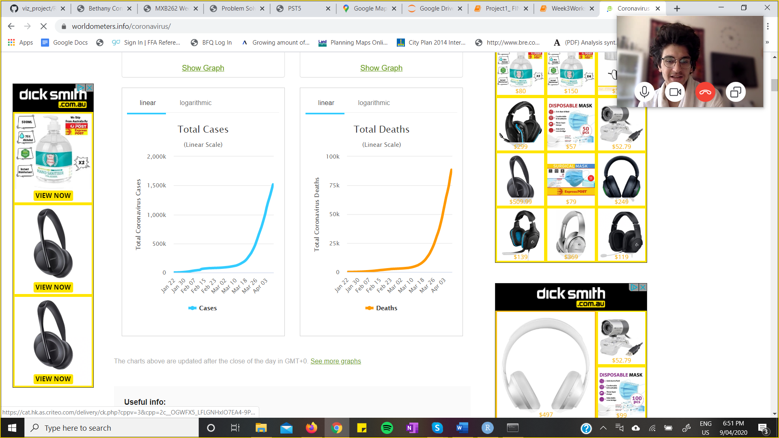
* Some general bar plots showing the distributions of the data is all we need, we will probably need to cut down on the data that we have though before we do this.

To be done for Tuesday:

* Bethany: mock up of the visualizations, explanation of the genre
* Luca: Matrix plot for the indicator’s dataset
* Jakob: What is the total size of your data? (MB, number of rows, number of variables, etc), What are other properties? (What is the date range? Is is it geo-data?, then a quick plot of locations, etc.), Daily cases plot (<https://www.worldometers.info/coronavirus/>)

Tuesday: start putting together a video

* Introduction (voiceover with some text and pictures)
* Mockups of the visualisation with explanation of the genres over the top (timelapse of drawing with voiceover)
* Implementation plan: Gantt chart with voiceover explanation over the top
* Walk through of preliminary data analysis: matrix plot, log plots and numerical information with voiceover

iMovie (mac)